

**US Army Corps of Engineers**

**Afghanistan Engineer District**

AED Design Requirements: Water Tanks & System Distribution

Various Locations, Afghanistan

SEPTEMBER 2009 Version 1.2

**TABLE OF CONTENTS**

AED DESIGN REQUIREMENTS FOR

WATER TANKS VARIOUS LOCATIONS, AFGHANISTAN

Section Page

**1. General 1**

**2. Water Tanks 1**

**3. Distribution System Requirements 1**

**4. Types of Storage 5**

**5. Water Requirements 7**

**6. Capacity of Water Supply System 8**

**7. Storage Requirements 8**

**8. Amount of Water Available Under Emergency Conditions 9**

**9. Elevated Storage Capacity 9**

**10. Water Distribution System Capacity Analysis 10**

**11. Shop Submittals As-Builts 11**

**12. References 12**

**Figures**

**Figure 1. Effects of Elevated Storage 4**

**Figure 2. Conventional Elevated Storage Tank 6**

**Figure 3. Single Pedestal Elevated Storage Tank 6**

**Tables**

**Table 1. Domestic Water Allowance 7**

**Table 2. Capacity Factors 8**

**Appendices**

**Appendix A Example Water Distribution Analysis 13**

**Appendix B Procedures for Leakage and Pressure Testing 17**

**1. General**

The purpose of this document is to provide water storage and distribution design requirements to Contractors for projects at USACE-AED projects. This is a summary of design and testing requirements for USACE-AED construction. Design procedures and examples can be found in the documents listed in the reference section.

**2. Water Tanks & Distribution Systems**

Water tanks may be required where a new water distribution system is proposed or as an upgrade to an existing water distribution system. Reference 1 provides design guidance specifically for water storage. Storage capacity of the water tank should meet peak flow requirements, equalize system pressures, and provide emergency water supply. The water supply system must provide flows of water sufficient quantity to meet all points of demand in the distribution system. To do so, pressure levels within the distribution system must be high enough to provide suitable pressure, and water distribution mains must be large enough to carry these flows. Reference 2 provides design guidance specifically for water distribution. Water storage facilities are constructed within a distribution network to meet the peak flow requirements exerted on the system and to provide emergency storage. Water supply systems must be designed to satisfy maximum anticipated water demands. The peak demands usually occur on hot, dry, and summer days when larger than normal amounts of water are used for irrigation and washing vehicles and equipment. In addition, most industrial processes, especially those requiring supplies of cooling water, experience greater evaporation on hot days, thus requiring more water. The necessary storage can be provided in elevated, ground, or a combination of both types of storage. Requirements for storage are discussed further in Section 7.

**3. Water Distribution System Requirements**

The Contractor shall install water distribution mains, branches, laterals, lines and service connections to include all pipe, valves, fittings and appurtenances, and pipe thrust restraint. Exterior water line construction shall include service to all buildings as described in the contract Scope of Work Section

01010. Distribution system designs must consider system operating pressure range; the pipe size and material, including joint construction and fittings; disinfection, and construction testing.

Pipe material is of importance from the standpoint of constructability, service life, and ease of maintenance. In USACE-AED projects PVC Schedule 80 pipe is the preferred material. This pipe has well documented experience in previous projects; it has superior strength and durability of over time to other thermoplastic pipe material, it is easily repaired, and materials including fittings are readily available in Afghanistan.

a) System Pressure Requirements.

Distribution systems shall provide system pressures that are neither too low 70 KPa (10 psi) for operating plumbing fixtures nor too high such that they are damaged. Pressure are measured at the building service connection; therefore pressures at this location must be generally in excess of 207

KPa (30 psi) for one to two story buildings considering internal pipe friction head losses.

1) Minimum pressures. Water distribution system, including pumping facilities and storage tanks or reservoirs, should be designed so that water pressures of at least 275 KPa (40 psi) at ground level will be maintained at all points in the system, including the highest ground elevations in the service area. Minimum pressures of 207 KPa (30 psi) under peak fixture flow conditions can be tolerated at the building farthest from the water source (tank or booster pump) as long as all peak fixture flow requirements can be satisfied at all locations. During firefighting flows, water pressures should not fall below 138 KPa (20 psi) at the hydrants, in new systems. Fire fighting capability is provided using hose streams at only a limited number of projects as specified in the contract.

2) Maximum pressure. Maximum water pressures in distribution mains and service lines should not normally exceed 517 KPa (75 psi) at ground elevation. Higher pressures require pressure reducing valves on feeder mains or individual service lines to restrict maximum service pressures to 517 KPa (75 psi).

3) Multiple pressure levels. If an extensive area has pressures higher than 517 KPa (75 psi) lower than 275 KPa (40 psi) under a single pressure level zone, it may be appropriate to divide the system into two or more separate zones, each having different pressure levels. Within each level, pressures within the distribution system should range from 275 KPa to 517

KPa (40 to 75 psi) at ground elevation.

b) Pipe Size and Material.

Pipe diameter is related to the design of adequate system pressure because the larger the pipe diameter the lower the friction head loss and therefore more service pressure availability. In addition, USACE water system planning technical criteria recognize good engineering judgment includes providing some safety factor in the design. The contract’s minimum size is desirable for future growth that the contractor cannot account for in their analysis, and their water distribution analysis cannot be verified until after construction; and even then at great effort. Water system models do not account for all system losses and operational circumstances. Furthermore, sizing water mains for the bare minimum when new means the system will be under sized as it ages in the future when pipe leaks and scale occur and other components such as valves and flow meters deteriorate. Unnecessarily small water main pipe diameters increase the booster pump horsepower requirements, energy costs for operation, and ultimately make water system sustainability more of an issue.

1) Pipe diameters and velocities. The minimum pipe diameter in the distribution system shall be 100mm (4 inch). The maximum velocity shall be 5 feet per second (1.5 meters per second) at 150% of the fixture unit flow or 2 times the average daily flow (8-hour basis), whichever is greater. The Contractor shall provide a water distribution system described as follows: Pipe diameters used in the network shall be 100mm or greater, as required to maintain proper system velocities and pressures between 275 KPa (40 psi) and 275 KPa (75 psi). Pipes for building service connections may be smaller diameter and shall be sized based on the fixture unit flows required for each building.

2) Pipe materials. The Contractor shall provide pipe of adequate strength, durability and be corrosion resistant with no adverse effect on water quality. Water distribution pipe material shall be PVC or Ductile Iron (DI). Ductile iron pipe shall conform to AWWA C104. DI fittings shall be suitable for 1.03MPa (150psi) pressure unless otherwise specified. Fittings for mechanical joint pipe shall conform to AWWA C110. The exterior surface of the pipe must be corrosion resistant. If DI pipe is installed underground pipe shall be encased with polyethylene in accordance with AWWA C105. Fittings and specials shall be cement mortar lined (standard thickness) in accordance with C104. Fittings for use with push-on joint pipe shall conform to AWWA C110 and C111. Polyvinyl Chloride (PVC) pipe shall conform to ASTM D 1785. Plastic pipe coupling and fittings shall be manufactured of material conforming to ASTM D 1784, Class 12454B. PVC screw joint shall be in accordance with ASTM D 1785 Schedules 80 and 120. PVC pipe couplings and fittings shall be manufactured of material conforming to ASTM D 1784, Class 12454B. Pipe for building service, less than

80mm (3 inch) may be screw joint and shall conform to dimensional requirements of ASTM D

schedule 80. Elastomeric gasket-joint, shall conform to dimensional requirements of ASTM D

1785 Schedule 80, All pipe and joints shall be capable of 1.03 MPa (150psi) working

pressure and 1.38 MPa (200psi) hydrostatic test pressure.

The only time HDPE and PVCu will be allowed in any AED project, including facility designs, water transmission pipelines, sewer force mains and non pressure pipe applications such as storm water or gravity sewers, is through an approved variation request submitted in accordance with Section 01335 of the contract. The variation request shall be submitted to

AED Engineering for approval. PVCu pipe material shall be specifically manufactured in accordance with specifications and labeled as Schedule 80 pipe according to ASTM D1785 specifications. Variation request shall include (among other items stated in Section 01335

3.6.4) the pipe material cell classification used in the product, the standard dimension ratio (SDR), the type of jointing being used, and the proposed use for the product (such as well casing or water distribution pipe lines). To be considered for a variation, HDPE pipe shall conform to Deutsche Institut fur Normung (DIN) 8074 Polyethylene Pipe - Dimensions and DIN 8075 Polyethylene Pipes – General quality requirements and testing (August 1999). Installation shall be as specified in AWAA M55 PE Pipe – Design and Installation. In the

absence of products or installation methods not meeting these standards, the contractor shall

provide documentation using the variations process in the contract section 01335 for approval prior to installation.

c) Pressure Provisions.

1) Elevated storage. Within the distribution system, elevated storage permits the well pumping to a tank to operate at uniform rates and without frequent start/stop cycles. The usefulness of elevated storage is shown in Figure 1. The system illustrated in Figure 1 (A) (without elevated storage) requires storage at the plant sufficient to provide for system demand rates in excess of the plant production rate, assuming the plant is operated at a uni- form rate. The pump station forces water into the service main, through which it is carried to three load areas: A, B, and C. Since all loads on the system are met without the use of elevated storage, the pump station must be capable of supplying the peak rates of water use to Areas A, B, and C, simultaneously, while maintaining the water pressure to Area C at a sufficient level. The minimum recommended pressure in the distribution system under non peak nonemergency flow conditions is 275 KPa (40 psi). Figure l (B) assumes the construc- tion of an elevated storage tank on the service main between Areas B and C, with peak loads in Area C and part of the peak load in Area B being satisfied from this tank. The elevation of the tank ensures adequate pressures within the system. The storage in the tank is replenished when water demands are low and the well (or pump station in the figure) can fill the tank while still meeting all flow and pressure requirements in the system. The Figure 1 (B) arrangement reduces required capacity of the booster pumps.

2) Booster pump pressure. Booster pump stations are sited downstream of ground level water tanks in order to provide the system operating pressure. Therefore they operate at the position shown in Figure 1A except that the pump total dynamic head (TDH) must be sufficient at the pump discharge to elevate the system pressure above the minimum pressure requirement at every location in the water system. Therefore compared to systems that have elevated storage, there is less uniformity in the system pressure and generally greater energy used to maintain system pressure than in a centrally located water tank. Booster pumping applications within AED shall have either a bladder style expansion or a hydropneumatic tank.

3) Most elevated storage tanks “float” on the distribution system. That is, the elevated tank is hydraulically connected to the distribution system, and the volume of water in the tank tends to maintain system pressures at a uniform level. When water use is high and booster pumping facilities cannot maintain adequate pressures, water is discharged from elevated tanks. Conversely, when water use is low, the booster pumps, which operate within a reasonably uniform head-capacity range, supply excess water to the system and the elevated storage is refilled. This condition is not normally encountered in designs in Afghanistan since it assumes that the booster pumps draw water from a source other than the elevated tank being filled.

Figure 1. Effects of Elevated Storage

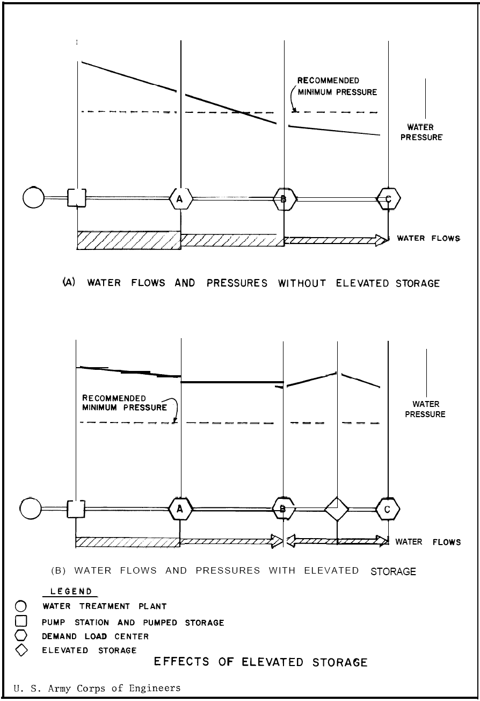

d) Valves and Thrust Restraint

1) System Isolation Valves. Valves (Gate valves w/box) shall be placed at all pipe network tees and cross intersections, and the number of valves shall be one less than the number of lines leading into and away from the intersection. For isolation purposes, valves shall be spaced not to exceed 3600 mm (12 feet) from tees or crosses. Gate valves shall be in accordance with AWWA C 500 and/or C509. Butterfly valves (rubber seated) shall be in accordance with C504. The valves and valve boxes shall be constructed to allow a

normal valve key to be readily used to open or close the valve. Provide traffic-rated valve boxes and concrete pad, 1 meter (3’-4”) square, for all valve boxes.

2) Air Release Valves. Air release valves are required to evacuate air from the main high points in the line when it is filled with water, and to allow the discharge of air accumulated under pressure. Vacuum relief valves are needed to permit air to enter a line when it is being emptied of water or subjected to vacuum. Contractor shall submit manufacturer’s data for properly sized combination air and vacuum release valves and determine their locations on the distribution system subject to review and approval of the Contracting Officer.

3) Blow-off Valves. The Contractor shall provide 40-50mm (1-5/8” – 2”) blow-off valves at ends of dead end mains. Valves should be installed at low points in the mains where the flushing water can be readily discharged to natural or manmade drainage ditches, swales or other.

Thrust restraint is required for pipe diameters 100 mm in diameter or larger. Restraint may be achieved by the type of joint system selected or by thrust blocking.

**4. Types of Storage**

Required storage capacity at military installations is met by use of elevated or ground storage. Examples of standard water tank construction at USACE-AED projects are shown in Figures 2 and 3. Elevated storage, feeds the water distribution system by gravity flow. Storage which must be pumped into the system is generally in ground storage tanks. Clear-well storage, which is usually part of a water treatment plant, is not included in computing storage unless sufficient firm pumping capacity is provided to assure that the storage can be utilized under emergency conditions, and then only to the extent of storage in excess of the 24-hour requirements of the treatment plant. Clear-well storage is used to supply peak water demand rates in excess of the production rate, and to provide a reservoir for plant use, filter backwash supply, and water supply to the system for short periods when plant production is stopped because of failure or replacement of some component or unit of treatment.

a) Ground Storage. Ground storage is usually located remote from the treatment plant (if one exists) but within the distribution system. Ground storage is used to reduce well or treatment plant peak production rates and also as a source of supply for re-pumping to a higher pressure level. Such storage for re-pumping is common in distribution systems covering a large area, because the outlying service areas are beyond the range of the primary pumping facilities. An example of a ground level reinforced concrete tank at USACE-AED projects is given in Figure 2. Ground level water tanks may be either reinforced concrete or steel construction. Ground storage tanks or reservoirs, below ground, partially below ground, or constructed above ground level in the distribution system, may be accompanied by pump stations if not built at elevations providing the required system pressure by gravity. There are a few projects in the USACE-AED project inventory that have partially below ground-level tanks. However, if the terrain permits, the design location of ground tanks at an elevation sufficient for gravity flow is preferred. Concrete reservoirs are generally built no deeper than 6.1-7.6 meters (20-25 feet) below ground surface. If rock is present, it is usually economical to construct the storage facility above the rock level. In a single pressure level system, ground storage tanks should be located in the areas having the lowest system pressures during periods of high water use. In multiple pressure level systems, ground storage tanks are usually located at the interface between pressure zones with water from the lower pressure zones filling the tanks and being passed to higher pressure zones through adjacent pump stations.

b) Elevated Storage. Elevated storage is provided within the distribution system to supply peak demand flow rates and equalize system pressures. In general, elevated storage is more effective and economical than ground storage because of the reduced pumping requirements, and the storage can also serve as a source of emergency supply since system pressure requirements can still be met temporarily when pumps are out of service. The most common types of elevated storage are elevated steel tanks, and standpipes. An example of an elevated steel tank at USACE-AED projects is given in Figure 3. Elevated storage tanks should be located in the areas having the lowest system

pressures during intervals of high water use to be effective in maintaining adequate system pressures and flows during periods of peak water demand. These are those of greatest water demand or those farthest from pump stations. Elevated tanks are generally located at some distance from the pump station serving a distribution pressure level, but not outside the boundaries of the service area, unless the facility can be placed on a nearby hill. Additional considerations for locating elevated storage are conditions of terrain, suitability of subsurface soil and/or rock for foundation purposes, and hazards to low-flying aircraft. Elevated tanks are built on the highest available ground, up to static pressures of

517 KPa (75 psi) in the system, so as to minimize the required construction cost and heights.

Figure 2. Ground Level Storage Tank

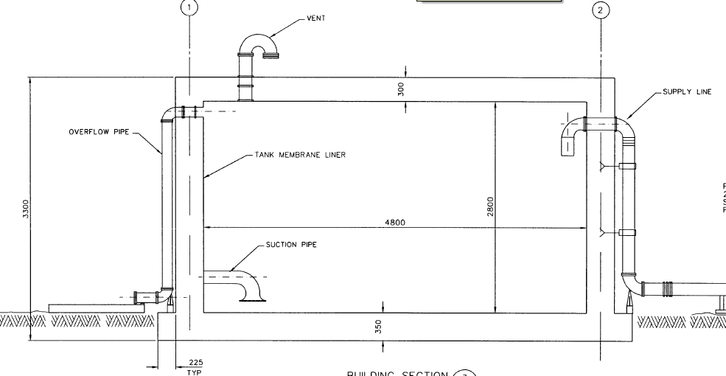

Provide external level indicator

Figure 3. Standard Elevated Storage Tank

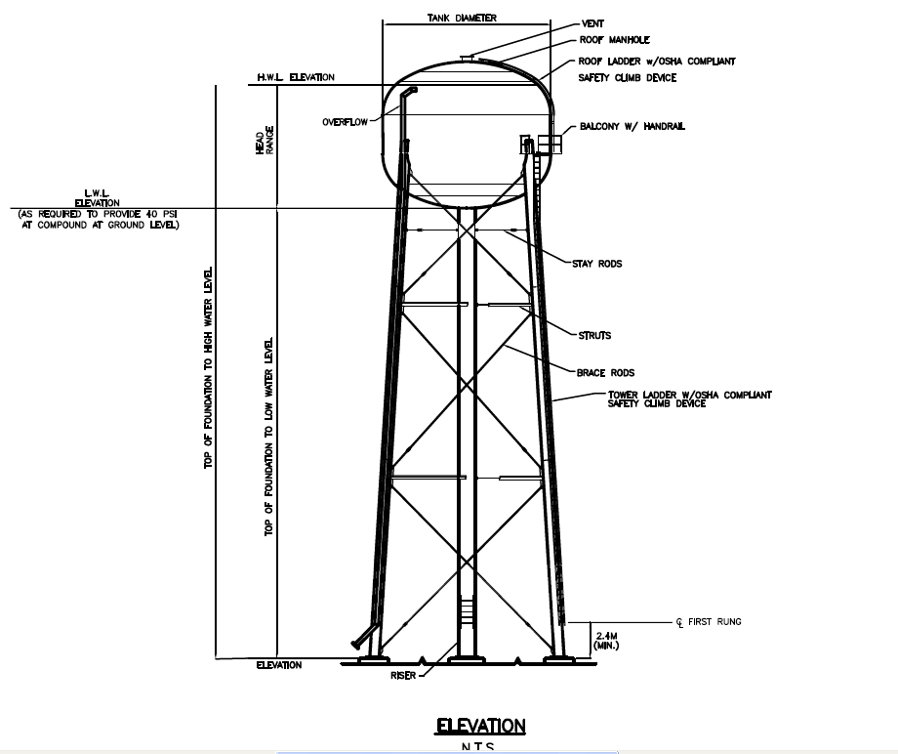

**5. Water Requirements**

The design of the water distribution systems shall be sized to provide flow and discharge based on a fixture unit basis or the basis of the average daily demand multiplied by the capacity factor, whichever is the greater. This flow is to be used to design facilities on an installation and is called the Average Daily Flow (ADF). The ADF is used to design installation water and wastewater systems and is calculated as the effective population x ADD x CF. These terms are defined below.

a) Domestic Requirements. The daily, per capita water requirements/allowances used in the design of facilities in Afghanistan are derived from Table 1 below unless stated differently in the contract technical requirements. These allowances do not include special purpose water uses, such as industrial, aircraft-wash, air-conditioning, irrigation, or extra water demands at desert stations. The term Average Daily Demand (ADD) and Domestic Water Allowance are terms used to quantify the volume of water used by an average individual at the facility being designed. These terms DO NOT include a capacity factor CF, described below in Table 2. If an individual ADD or water allowance is defined in the Scope of Work or Technical Requirements, that value in the Contract shall be used for design calculations and not the value provided in Table 1. In either case, a capacity factor (see Paragraph 6, Table 2) should be applied when making design and sizing calculations.

b) Fire-Flow Requirements. Fire flow demand will generally not be included in the sizing of water storage facilities except where specifically stated in the contract technical requirements. In those cases a stand-alone water storage tank may be required in the technical requirements. In this case only, the system must be capable of supplying the fire flow specified plus any other demand that cannot be reduced during the fire period at the required residual pressure and for the required duration. The requirements of each system must be analyzed to determine whether the capacity of the system is fixed by the domestic requirements, by the fire demands, or by a combination of both. Where fire-flow demands are relatively high, or required for long duration, and population and/or industrial use is relatively low, the total required capacity will be determined by the prevailing fire demand. In some exceptional cases, this may warrant consideration of a special water system for fire purposes, separate, in part or in whole, from the domestic system. However, such separate systems will be appropriate only under exceptional circumstances and, in general, are to be avoided.

**Table 1. Domestic Water Allowance/Average Daily Demand (ADD)**

Liters/Capita/Day (Gallons/Capita/Day)

Enduring

Base

Contingency

Base

U.S. Forces Coalition Forces ANA

ANP Dining Facility1

Wash Racks2

Vehicle Maintenance

285 (75)

190 (50)

155 (41)

155 (41)

# of meals x rate/meal

# of vehicles x rate/vehicle

20 (5)/vehicle

190 (50)

115 (30)

95 (25)

95 (25)

# of meals x rate/meal

# of vehicles x rate/vehicle

20 (5)/vehicle

Notes:

1Rate/meal shall be 2 liters (0.5 gallons) for breakfast, 4 liters (1 gallon) for lunch and 8 liters (2 gallons) for dinner.

2Rate/vehicle shall be 75 liters (20 gallons) for cars small trucks, 115 liters (30 gallons) for large trucks and 190 liters (50 gallons) for aircraft.

c) Irrigation Requirements. The allowances indicated in Table 1 include water for limited watering for planted and grassed areas. However, these allowances do not include major lawn or other irrigation uses. Lawn irrigation provisions for facilities, such as family quarters and temporary structures, in all regions will be limited to hose bibs on the outside of buildings and risers for hose connections. Where substantial irrigation is deemed necessary and water is available, underground sprinkler systems may be considered. Where irrigation requirements are justified in arid or semi-arid regions, such irrigation quantities will be included as an industrial water requirement and not as a domestic requirement.

**6. Capacity of Water Supply System**

In order to account for fluctuations in water use at facilities, a safety or capacity factor (CF) is introduced into the design calculations. Capacity factors, as a function of "Effective Population" are shown in Table 2, as follows:

Table 2. Capacity Factors (CF)

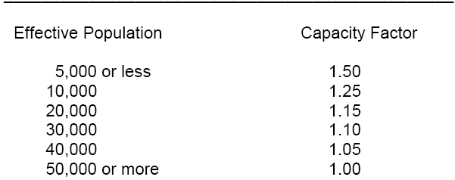

Per the UFCs, the "Capacity Factor" will be used in planning water supplies for all projects, including general hospitals. The proper "Capacity Factor" as given in Table 2 is multiplied by the "Effective Population" to obtain the "Design Population." For example, a facility with a planned (effective population) of 93 persons would be considered to have a design population of 93 x 1.5 = 140. Capacity factors and Design Populations will be used in calculating the ADF, capacity of the supply works, supply lines, treatment works, principal feeder mains and storage reservoirs. Taking this into account, the required storage volume for a facility with 93 assigned personnel, would be 93 persons multiplied by the ADD of 155 liters per person per day (Table 1), multiplied by the capacity factor (CF) of 1.5 (Table 2), which means, 93 x 155 x 1.5 = 21.62 cubic meters (5,710 gallons). It should be stressed again that ADD values provided in the contract documents shall be used when given, but

that capacity factors must be applied unless specifically excluded in those contract documents. When necessary, arithmetic interpolation should be used to determine the appropriate Capacity Factor for intermediate project population. (For example, for an "Effective Population" of 7,200 in interpolation, obtain a "Capacity Factor" of 1.39.) Capacity factors will NOT be used for hotels and similar structures that are acquired or rented and troop housing. Capacity factors will NOT be applied to fire flows, irrigation requirements, or industrial demands.

**7. Storage Requirements**

The amount of water storage provided will conform to the requirements set forth herein. Storage requirements for MILCON projects are explained in Reference 1. Requirements for ANP and ANA vary, but are typically a minimum provision of one (1) day average daily flow which is the ADD multiplied by the effective population (c) multiplied by the capacity factor (ADD x c x CF). In all projects, the storage requirements stated in the contract technical requirements (Section 01015) shall be multiplied by the capacity factor unless specifically stated otherwise.

In general for MILCON projects, total storage capacity, including elevated and ground storage, will be provided in an amount not less than the greatest of the following items.

Item 1: One hundred percent (100%) of the ADF (ADD x c x CF) plus all industrial requirements. This will provide minimum operational storage needed to balance average daily peak demands on the system and to provide an emergency supply to accommodate essential water needs during minor supply outages of up to a one-day duration. For the purposes of this item, essential water needs do not include the fire demand.

Item 2: The fire demand is the required fire flow needed to fight a fire in the facility (including water required to support fire suppression systems) which constitutes the largest requirement for any facility served by the water supply system; plus 50 percent of the average domestic demand rate plus any industrial or other demands that cannot be reduced during a fire period. This amount will be reduced by the amount of water available under emergency conditions during the period of the fire. The fire demand quantity must be maintained in storage for fire protection at all times except following a fire fighting operation when the fire demand quantity would be depleted. It is recognized that during daily periods of peak consumption due to seasonal demands, the amount of water in storage will be less than full storage capacity; however, conservation methods will be instituted to prevent drawdown of water in storage below the fire demand quantity. Fire demand flow may not be included in the project; check the Section 01015 technical requirements for provision of fire flow demand.

**8. Amount of Water Available Under Emergency Conditions.**

Where the water supply is obtained from wells, all of which are equipped with standby power and located within the distribution system, the emergency supply will be considered as the quantity available from all but one of the wells. Where one well has a capacity greater than the others, that one will be assumed out of service. Where only 50 percent of the wells have standby power, the emergency supply will reconsidered as the quantity available from the wells having standby power.

**9. Design and Construction of Water Storage Facilities**

All treated water reservoirs must be covered to prevent contamination by dust, birds, leaves, and insects. These covers will be, insofar as possible, watertight at all locations except vent openings. Special attention should be directed toward making all doors and manholes watertight. Vent openings must be protected to prevent the entry of birds and insects; and vent screens should be kept free of ice or debris so that air can enter or leave the reservoir area as temperature and water levels vary. All overflows or other drain lines must be designed so as to eliminate the possibility of flood waters or other contamination entering the reservoir. Reservoir covers also protect the stored water from sunlight, thus inhibiting the growth of algae. Further prevention of algae growth or bacterial contamination, due to the depletion of the chlorine residual, can be obtained by maintaining sufficient flow through the reservoir so that water in the reservoir does not become stagnant. Minimal flows through the reservoir also help to prevent ice buildup during cold periods.

All storage tanks will be provided with external level indicators to prevent overflows during filling. Depending upon the contract requirements, either level controls to the well pump motor control panel or altitude valves shall be used to control overflows of the water tank. If the contract technical requirements specifically state that altitude valves shall be used, these altitude valves will be installed in concrete pits having provision for draining either by gravity or pumping. Water tank drains and overflow piping will not be connected to sanitary sewers. Every precaution will be taken to prevent the collection of water from any source in valve pits.

Storage measurements are used for monitoring, inventory, and system controls. Elevated and ground storage measurements will be made by either external mechanical level indicators or pressure sensitive instruments directly connected by static pressure lines at points of no flow. Underground storage measurements will be made by air bubbler back pressure sensitive instruments or by float actuated instruments. The direct pressure measurements of elevated tanks will be suppressed to readout only the water depth in the elevated bowl. High and low level pressure sensitive switches will be used for alarm status monitoring and for pump cut-off controls. Intermediate level switches, pres-

sure or float actuated, will be used for normal pump controls. High storage level will initiate the shut- down of supply pumping units and actuation of an overflow alarm in that order. Low storage level will initiate startup of supply pumping or well pumping units or distribution pumping unit shutdown.

Potable water storage facilities, associated piping, and ancillary equipment must be disinfected before use. Disinfection will be accomplished following procedures and requirements of the contract specifications. In no event will any of the above equipment or facilities be placed in service prior to verification by the supporting medical authority, by bacteriological tests, that disinfection has been accomplished.

Leakage tests shall be conducted prior to acceptance of the completed water system. Procedures for storage tank leakage testing are contained in Appendix B.

**10. Water Distribution System Design Capacities and Requirements**

The sizing and location of water mains, booster pump stations, and elevated storage facilities are dependent upon hydraulic analyses of the water distribution system.

Features of the water system shall be sized to provide flow or storage capacity as follows:

• Water Well Pump Capacity - Capacity and total dynamic head (TDH) shall be based on an adjusted ADF (ADD, times the population, times the capacity factor over a 16 hour period).

• Water Tanks - Capacity shall be based on ADF (ADD x c x CF). (NOTE: If a minimum volume of storage is provided in the contract documents, that value is to be taken as the average daily storage capacity and will be multiplied by the capacity factor to determine the actual required storage volume for the facility.)

• Booster Pumps – For installations with fewer than 400 persons, the capacity of each pump shall be 50% of the installation wide, total fixture unit flow. For installations with greater than

400 persons, the capacity of each pump shall be 50% of the installation wide, total fixture unit

flow or 2 times the adjusted average daily flow (16 hour basis), whichever is greater. Provide three identical pumps. Each pump shall be sized to deliver the calculated capacity. Pumps shall automatically alternate to distribute wear. Provide variable frequency drives or pressure controller and automatically turn pumps on and off based on flow demand and system pressures. Unless stated otherwise in the contract documents, the total dynamic head (TDH) of the booster pumps shall be calculated to maintain a minimum, system pressure of 40 psi at all points in the distribution system assuming 2 pumps are operating at the specified flow. Either a bladder style expansion tank or a hydro-pneumatic tank shall be supplied when booster pumps are used in the water system.

• Hydro-pneumatic tanks – Volume and pressure regulation to maintain a pressure range provided in the technical requirements based on a rate equal to the ADF (ADD x c x CF).

• Water Mains – Diameter based on the installation fixture unit flow or two times the ADF (ADD x c x CF) and velocity requirements per this guide unless a minimum diameter is specified which is adequate to provide flow and meet the specified maximum velocity. The flow through the system shall be distributed on the basis of fixture unit flow in each the buildings serviced or per contract

• Water Service Lines - Diameter based on fixture units of the building serviced or per contract

Technical requirements for water distribution systems design are provided in Reference 2 and may also be summarized in the contract technical requirements. Other AED Design Guides discuss the

sizing of booster pumps and hydro pneumatic tanks (see references). For all but single pipe water transmission lines to one or two individual buildings, water distribution computer programs should be used to evaluate the water system hydraulic design. An excellent program developed by the U.S. Environmental Protection Agency is available on the internet at the location shown in Reference 5.

Water distribution models are based on assumed values for many parameters, simplifications of the actual physical system, and unknowns concerning future demands. They are therefore inexact representation of the real world and must be used with conservatism applied to the results. Water system models do not account for all system losses and operational circumstances. For example partially closed gate valves, fitting losses, and the growth of scale in the pipes due to the very hard water quality in Afghanistan are not considered in water models. Furthermore, sizing water mains for the bare minimum when it is new means the system will be under sized as it ages in the future when pipe leaks occur and other components deteriorate.

Appendix A contains an example of the information to be provided for USACE-AED project design analysis reports. The critical information that shall be shown is listed below:

1. Network model representation – a drawing (with accompanying graphic scale) showing the valves, fittings, water tanks, pumps, demand nodes, and pipes (both gridiron and dead end) lines that convey water to demand nodes;

2. A table showing the water demand flow rates at each demand node, the node ground elevations, the pipe length, diameter, and pipe hydraulic roughness coefficients assumed for the model, the tank ground elevations and water level above ground elevations, pump capacity and total dynamic head rating based on the proposed pump curve for the pump

3. A pipe table showing the flow velocity obtained during the simulation

4. Design assumptions such as the basis of the flow rates, the water tank water level, and the number of pumps in operation (e.g. duty and jockey pumps)

5. For existing water distribution systems where the project(s) are being upgraded with additional facilities (barracks or admin buildings, maintenance facilities, or recreational facilities) the existing system pressures as measured or estimated based on booster pump gauges or water level elevations in existing water tanks shall be documented.

Water pressure measurements at existing facilities should include gauge readings taken at locations as close to the new water use facilities. Equipment for monitoring pressure is shown in Appendix B.

**11. Shop Submittals and As-Builts**

After the completion of any water distribution system all piping and water storage facilities, testing shall be provided per contract specification. Water pipes shall be tested for leakage and hydrostatic pressure performance. Storage tanks shall be tested for leakage performance. Appendix B provides test examples and report forms for use at USACE-AED projects.

Shop submittal shall include the following tests, products and materials:

• Substitutions of pipe material and fittings different from contract technical requirements

• Water pipe pressure and leakage tests reports (see Appendix A for example)

• Water tank leakage tests reports (see Appendix B for example)

• Tank installation drawings with complete details of steel, pipe and concrete work if different than standard drawings. Note for site adapt projects where standard drawings and specifications for water tanks have been prepared; substitutions are not allowed.

• Certifications that internal linings or coatings that come in contact with the potable water comply with NSF 61 (see reference 10). Section 5 Barrier Materials specifically covers products and materials such as coatings and paints applied to storage tanks; linings, bladders and diaphragms in hydro-pneumatic tanks; and constituents of concrete and cement

mortar, blended sealers and admixtures that are field applied or factory applied to precast or cast in place concrete.

Upon completion of installing the water tank system, The Contractor shall submit editable CAD format As-Built drawings. The drawing shall show the final product as it was installed in the field, with the exact dimensions, locations, materials used and any other changes made to the original drawings. Refer to Contract Sections 01335 and 01780A of the specific project for additional details.

**12. References**

1. UFC 3-230-09a Water Supply: Water Storage, January 2004

2. UFC 3-230-04a Water Distribution, January 2004

3. UFC 3-230-03a Water Supply, January 2004

4. Comprehensive Water Distribution Systems Analysis Handbook, MWH Soft

5. US EPA. EPANET – Users Manual, EPA-600/R-00/057, September 2000

Available at <http://www.epa.gov/nrmrl/wswrd/dw/epanet.html>

6. AED Design Requirements - Booster Pumps, March 2009

7. AED Design Requirements - Chlorinators, March 2009

8. AED Design Requirements - Hydro-Pneumatic Tanks, March 2009

9. AED Design Requirements - Jockey Pumps, March 2009

10. National Science Foundation, NSF/ANSI 61 – 2008, Drinking Water System Components – Health Effects

11. UFC 3-230-13a Water Supply Pumping Stations, January 2004

Appendix A Example Water Distribution Analysis

The following illustration shows the proposed water plan for a project:

Water Distributi on Hydraulic Analysis Examp e Network Descripti on Tabl e

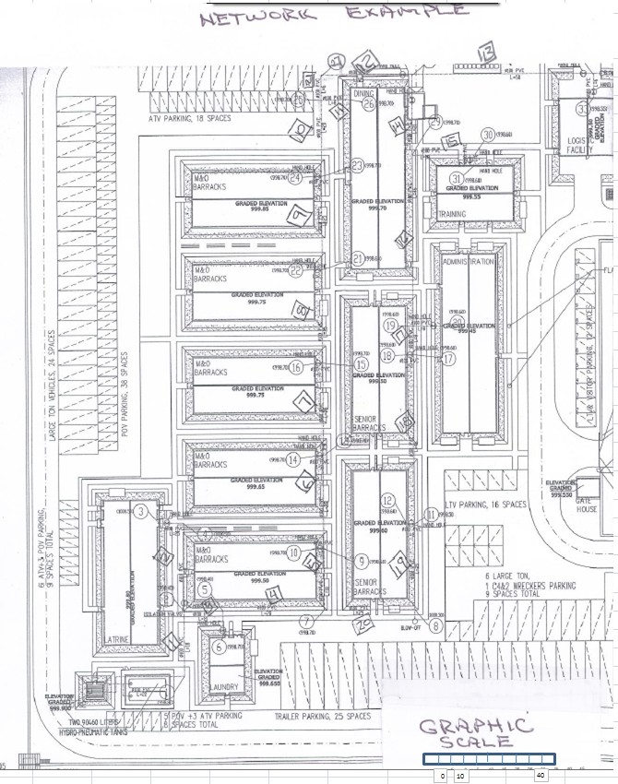

Fixture

Node # Type

Ground Demand. Fixture Fixture

Na me Elevation,m 1/s Units Fraction

Pi pe #

Diameter.

length, m Rougness,C

|  |  |  |  |  |  |  |  |  |  |  |  |  |
| --- | --- | --- | --- | --- | --- | --- | --- | --- | --- | --- | --- | --- |
|  | Jurn::t on  Jun n on | BPStil | 9'38.80  998.40 |  |  |  |  | 100 | 18 | 145 |  | |
| Demand | latri ne | 1000.50 | 5.01 | 376 | 0.52 |  | 100 | 18 | 145 | 51.51% | 0.777 |
| Demand | Laundry | 998.70 | 1.20 | 90 | 0.12 |  | 100 | 11 | 145 | 12.33% | 0.186 |
| Junc t on |  | 998.70 |  |  |  |  | 100 | 28 | 145 |  |  |
|  | Midd e |  |  |  |  |  |  |  |  |  |  |
| 10 | Demand | Barracks | 998.70 | 0.16 | 12 | O.Q2 |  | 100 | 18 | 145 | 1.64% | 0.025 |
|  |  | Midd e |  |  |  |  |  |  |  |  |  |  |
| 14 | Dema nd | Barracks | 998.70 | 0.16 | 12 | 0.02 |  | 100 | 25 | 145 | 1.64% | 0.025 |
|  |  | Midd e |  |  |  |  |  |  |  |  |  |  |
| 16 | Demand | Barracks | 998.70 | 0.16 | 12 | O.Q2 |  | 100 | 25 | 145 | 1.64% | 0.025 |
|  |  | Midd e |  |  |  |  |  |  |  |  |  |  |
| 22 | Demand | Barracks | 998.70 | 0.16 | 12 | O.Q2 |  | 100 | 25 | 145 | 1.64% | 0.025 |
|  |  | Midd e |  |  |  |  |  |  |  |  |  |  |
| 24 | Demand | Barracks | 9'98.70 | 0.16 | 12 | 0.02 |  | 100 | 25 | 145 | 1.64% | 0.025 |
| 25 | J unction |  | '998.70 |  |  |  | 10 | 100 | 20 | 145 |  |  |
| 27 | J u-nction |  | '998.70 |  |  |  | 21 | 100 |  | 145 |  |  |
| 26 | Demand | D ning | '9'98.70 | 0.43 | 32 | 0.04 |  | 100 |  | 145 | 4.38% | 0.066 |
| 28 | J unction |  | '998.70 |  |  |  | 12 | 100 | 31 | 145 |  |  |
| 32 | Dema nd | logistics | '998.60 | 0.16 | 12 | O.Q2 | 13 | 100 | 56 | 145 | 1.64% | 0.025 |
| 29 | J u nction |  | '9'98.70 |  |  |  | 14 | 100 | 21 | 145 |  |  |
| 30 | Demand | Training | '998.60 | 0.16 | 12 | 0.02 | 15 | 100 | 18 | 145 | 1.64% | 0.025 |
| 19 | Demand | Admin  Senior | '998.60 | 0.80 | 60 | 0.08 | 16 | 100 | 46 | 145 | 8.22% | 0.124 |
| 18 | Dema nd | Barracks  Senior | '998.60 | 0.5'9 | 44 | 0.06 | 17 | 100 |  | 145 | 6.03% | 0.091 |
| 12 | Demand | Barracks | '998.60 | 0.5'9 | 44 | 0.06 | 18 | 100 | 46 | 145 | 6.03% | 0.091 |
|  | J u nction |  | 1000.30 |  |  |  | 19 | 100 | 25 | 145 |  |  |
|  | J unction |  | '998.70 |  |  |  | 20 | 100 | 25 | 145 |  |  |
|  |  | Sum |  | 9.71 | 730 |  |  |  | 503 |  | 100.00% | 1.51 |

'% Total

Dema nd

2:xAOD

Demand, l/s

Demand compari son for booster pump

Based on fixture basis Factor (2x ADD)

35.00

9.72

m•3/h

1/s

6.4

0.16

Based on 2 x ADD basi s (16 hour operati on)

|  |  |  |
| --- | --- | --- |
| 5.43 | m'3/h | 1.0 |
| 1.51 | 1/s |  |

|  |  |  |
| --- | --- | --- |
| population | 305 | capita |
| water usage | 190 | per ca pita -day |
| capacity factor | 1.5 | ratio |
| total ADD | 85,925 | liter /day |
|  | 85.925 | m3'/day |

The objectives of the simulation for the system include:

1 Verifying the minimum diameter for the distribution piping is large enough to minimize head loss throughout the system such that the technical criterion for minimum pressure is achieved. This is to be done with the minimum amount of elevated tank or booster pump energy requirements to minimize operation and maintenance cost, for example the booster pump energy required to operate the generators powering the motors.

2 Verifying the maximum flow velocities are not excessive per the technical requirements to minimize peak pressure surges associated with equipment and system operation (for example pump shutoff) that can separate joints and damage plumbing fixtures if excessive pressures

occur.

3 Verifying booster and jockey pump selection.

4 Verifying the heights assumed for elevated tanks are adequate.

The project EPANET file is created (see user’s manual for detailed instructions, Reference 5) by using the following steps:

1 Set the design units to SI and defaults and labels

a. Under project pull down tab edit the following

i. Hydraulics – set head loss form to Hazen Williams (H-W) and flow units to liter per second (L/S)

ii. Properties – set pipe length to 25 (meters) and roughness to 145 (conservative value for C value to approximate fitting losses not included)

b. Under summary – add project title and notes

2 Add pipe junctions (nodes) using the node creation tool on the tool bar – note EPANET automatically enters a number for each node when enters using the tool which can be edited to make the EPANET model numbering scheme identical to the designers numbering scheme

on the water site plan. Enter for each node:

a. Grade elevations for each node location b. Base water demands

c. Additional nodes to later connect the reservoir to the booster station

3 Connect the nodes with pipes using the pipe creation tool on the tool bar

a. Check that the correct roughness (Hazen William C value) appears in the Browser dialogue box b. Adjust the length of the pipe to the correct value determined from the site plan

4 Add a water tank or reservoir as required by the project using the appropriate tool from the tool bar

a. Use a water tank if the project includes an elevated tank; a reservoir is the choice if the project contains a ground-level reservoir b. Set the grade elevation, initial water level and minimum and maximum water levels in the tank

c. Set the total head (HGL elevation) for the ground level reservoir

5 Enter the pump by using the pump tool to drag a connection between the first downstream node from the reservoir to the first node in the water distribution system connected to the pump. Enter pump information in the Brower dialogue box. Create a pump curve number to enter information for the booster pump from the manufacturer’s pump curve.

6 The first simulation should be based on the booster pump design criteria

7 A second simulation (not shown here) should be based using a low flow rate for the jockey pump operation

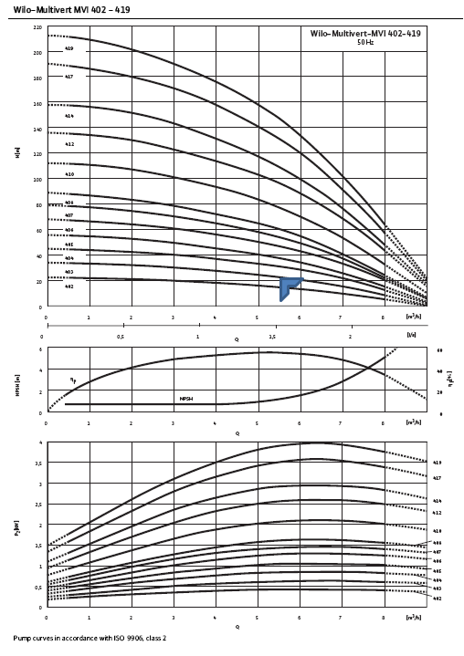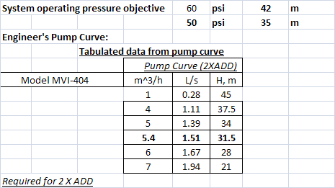

27 0 01 28 13

**5.19** 12 0.00

21 **5.19**

01

5 22

,o.o1

**5.19**

**0.01** .19

14

10

Example Water Distribution - 2x ADD 0 02

15

rO.D1 r25.00

•

24 **5.19** 0.00 .29

*·r*

0.05 30.00 0 02

•

16

0.10

35.00

·22

0.15 40.00

m/s m

·r

0 02

16 •

0.00

9

**l**0 03**'**

5.29

0 01

18

17

**0**

14 5.29

**l'**

3.39 0 02

18

**0.10**

0 03

**l'**10

12

i-1

0 03

5 19

• •

6 4

Ill Ill

t **0**2**0**9**4**

.

1 0 5.49

0. 9

0.09 **35.19 0.07 35.19**

20

**004**

0

33.59

**0.19**

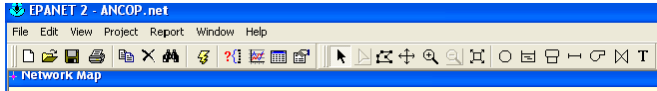

11

0.00 **35.10**

Appendix B Procedures for Leakage and Pressure Testing

Hydro static pressure test form

*This form is to be used onl y for h ydrostatic tests per AWWA C600*

Procedure

1. Fol lowing the installation of any new pipeline, all ne w ly laid pipe or valved section shall be subjected to a pressure and leakage test

The section being tested sha ll be described on the test form. The information to be included shall be as show n on the form. Do not state "not applicable "

2. Each valved section of pipeline shall be slowly f illed with water. The specfied test pressure in the contract techncial requirements shall be applied using a suitable pump.

3. Before applying the final test pressure (1,378 Kpa or 200 psi) unless stated otherw ise in contract, air shall be ex pelled completely from the pipeline section under test

4. The pipeline shall be allowed to stabiliz e at the test pressure. The test pressure shall not be allowed to vary by plus or minus 34.5 K pa ( 5 psi) for a period of one (1) hour.

5. A pressure test apparatus simlar to the one shown in the Figure 1shall be connected to the test section at either a hose bib or bl ow off valve location using appropriate fittings

6. Test pressure shall be maintained w ithin th the tolerance stated in step 4 for a minimum one hour duration (or l onger if required in the cntract techncial requirements)

7. Pressure readings at 15 minute intervals shall be recorded as shown on the hydrostatic pressure test form e xample in Figure 2; a blank form is provided in Figure 4.

8. Leakage test shall be conducted followng the pressure test. Leakage test pressure shall be 1034 K pa (150 psi) unless state otherwise in the contract.

9. If any air has been introduced into the line, expelI the air as it coul d affect the ability to conduct a successful test.

10. The test leakage shall not exceed the volume computed as shown below in Figure 3 for a period of two (2) hours.

Figure 1Hydraulic pressure and leakage test apparatus

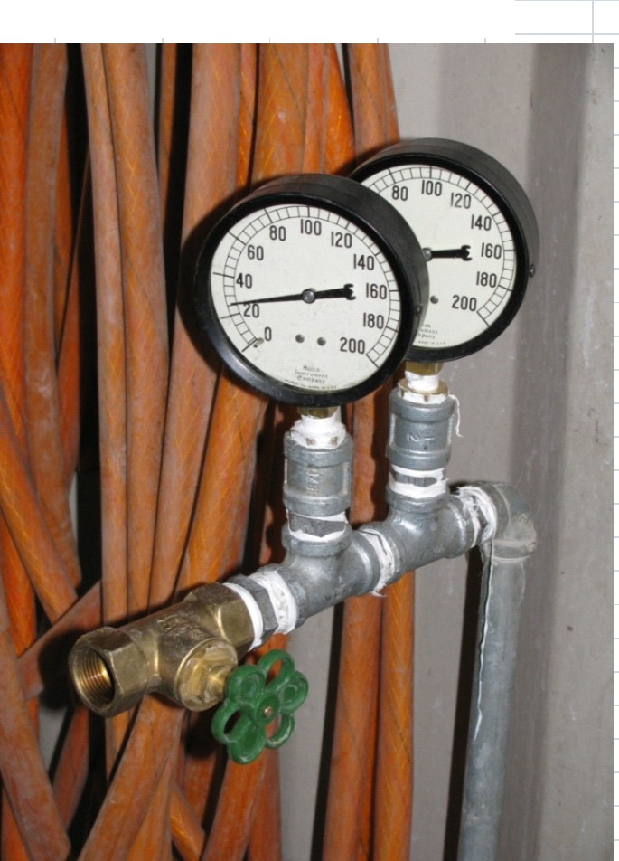

Figure 2 Hydraulic pressure and leakage test form completion example

Test Information (shall be printed including names) Project name and l ocation

Pressure test data *Interval*

St a rt of tes t

*Time (h:ml Test oressur*

1378

Contract number Date of test Location of test

Name of hydraulic test supervisor:

Name of witness

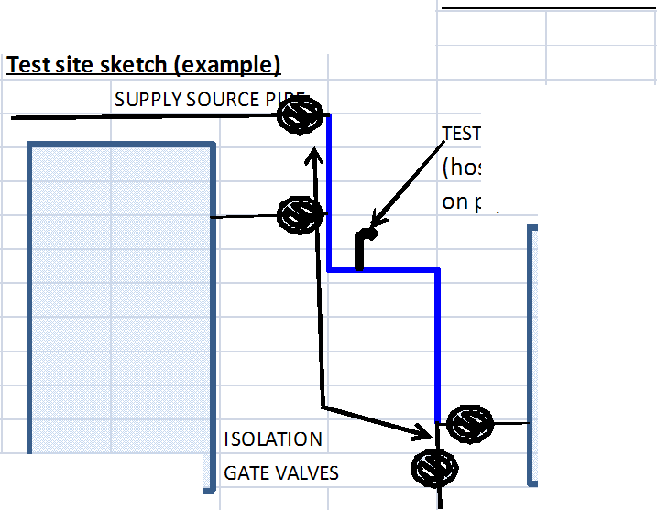

1st 15 m i n

2 n d 15 m i n --------

3rd15m i n Co m pl et ion oftest -------,- - ---:

Leakage test data *!n1J:rygJ*

St art of tes t

*Time (h:ml Test oressur*

10 34

APPARATUS /PUMP CO NNECTION

(hose bibb or bl ow-off valve on pipe to be tested)

1st 15 m i n

2 n d 15 m i n --------

3rd15m i n --------

4t h 15 m i n --------

5t h 15 m i n

Note:pressure test pump connection shall be made to the inlet tee (run) using threaded connection from the pump

P rovide sufficient reservoir of water to run test including filling pipe line (if empty) plus allowable leakage in Figure 3

E XISTING RES BLDG NEW ADMIN BLDG

Pipe Test Data

Length 100 m

Diameter 100 mm

6t h 15 m i n --------

7t h 15 m i n --------

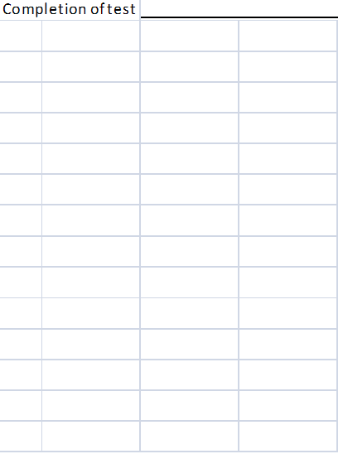

**Figure 3 Allowable leakage Figure 4 Blank Test Form**

Based on formula: **Test Information (shall be printed including names) Pressure test data** *Interval Time (h:m) Test pressur*

Allowable leakage in liters per hour, L=(1/794797)*S*D*P^0.5 Project name and location Sta rt of tes t 1378

S= length, D = pipe diameter P= 1034 Kpa Contract number 1s t 15 min

Nomin al

d i a me te r, mm

Nomin al

d i a me te r, in

Le ngth of pi pe , m

allowab le le akage ,

l i te r/hour

allowab le le akage ,

lite r/

2hour mi l l i l i ters

Date of test

Location of test 2nd 15 min

Name of hydraulic test supervisor:

Name of witness 3rd 15 min

50 2.0 50 0.1011 0.2023 202

100 0.2023 0.4046 405

150 0.3034 0.6069 607

200 0.4046 0.8092 809

250 0.5057 1.0114 1,011

300 0.6069 1.2137 1,214

75 3.0 50 0.1517 0.3034 303

100 0.3034 0.6069 607

150 0.4552 0.9103 910

200 0.6069 1.2137 1,214

250 0.7586 1.5172 1,517

300 0.9103 1.8206 1,821

100 3.9 50 0.2023 0.4046 405

100 0.4046 0.8092 809

150 0.6069 1.2137 1,214

200 0.8092 1.6183 1,618

250 1.0114 2.0229 2,023

300 1.2137 2.4275 2,427

110 4.3 50 0.2225 0.4450 445

100 0.4450 0.8901 890

150 0.6676 1.3351 1,335

200 0.8901 1.7802 1,780

250 1.1126 2.2252 2,225

300 1.3351 2.6702 2,670

120 4.7 50 0.2427 0.4855 485

100 0.4855 0.9710 971

150 0.7282 1.4565 1,456

200 0.9710 1.9420 1,942

250 1.2137 2.4275 2,427

300 1.4565 2.9130 2,913

150 5.9 50 0.3034 0.6069 607

100 0.6069 1.2137 1,214

150 0.9103 1.8206 1,821

200 1.2137 2.4275 2,427

250 1.5172 3.0343 3,034

300 1.8206 3.6412 3,641

**Test site sketch** Completion of tes t

**Leakage test data** *Interval Time (h:m) Test pressur*

Sta rt of tes t 1034

1s t 15 min

2nd 15 min

3rd 15 min

4th 15 min

5th 15 min

6th 15 min

7th 15 min

Completion of tes t

**Pipe Test Data**

Length m

Diameter mm

Tank Leakage Test

Reference: Underwriters Laboratory Method 142, 2007

Procedure

1. Following the installation of any new steel (welded or bolted water tank), a leakage test shall be performed in accordance with the manufacturer's recommendation. If there are no manufacturer's recommendation, one of the leakage test methods based on UL 142 as decribed below shall be used. Low Pressure Hydrostatic Test Option

a) A low pressure hydrostatic test shall be conducted on the full tank. The tank shall be filled to overflow and the outlet and drain valves securely closed

A sump pump shall be used to fill the tank by pumping from a barrel of chlorinated fresh water through a hose inserted into the air vent pipe above until the vent starts to overflow- then the pump shall be shut off. The pressure gauge at the well should be allowed to exceed 55 to 69 KPa (8 to 10 psi) The pressure gauge at the supply source shall be monitored for drop in pressure for one hour during which time the seams and joints will be

monitored for water leaks; leaks shall be marked with either spray paint of water proof marking pens and noted on the test form

If the pressure drops more than 14 Kpa (2 psi) in the one hour test period, the first trial leakage test shall be indicated as having failed on the test form

A second trial shall be repeated once. A second failure shall be cause for rejection of the tank watertightness integrity

Low Pressure Air Test Option

b) A low pressure air test shall be conducted on the empty tank. The tank shall be drained of water using the tank drain

All external vent pipes and drains that are not closed by valves shall be blinded with threaded caps, inflatable pipe plugs or gasketed blind flanges

An air compressor shall be used to pressurized the tank to between 10 to 14 KPa (1.5 to 2 psi) using a fitting on the end of the drain pipe

A soap-based water solution consisting of one part hand soap mixed with 10 parts clear water shall be made and applied to the all joints and tank seams

A pressure gauge at the air supply source shall be monitored for drop in pressure for one hour during which time the seams & joints will be monitored for bubbles indicating air leakage from these joints;leaks shall be marked with spray paint of marking pens- and noted on the test form The visual identification of air bubbles at the seams/ joints or a drop of pressure to zero will indicate leakage which

shall be cause for rejection of the tank watertightness integrity

Figure 1Hydraulic leakage test setup

WELL HOUSE WATER STORAGE TANK

OVERFLOW (3'1 6'150 LBS GATE \

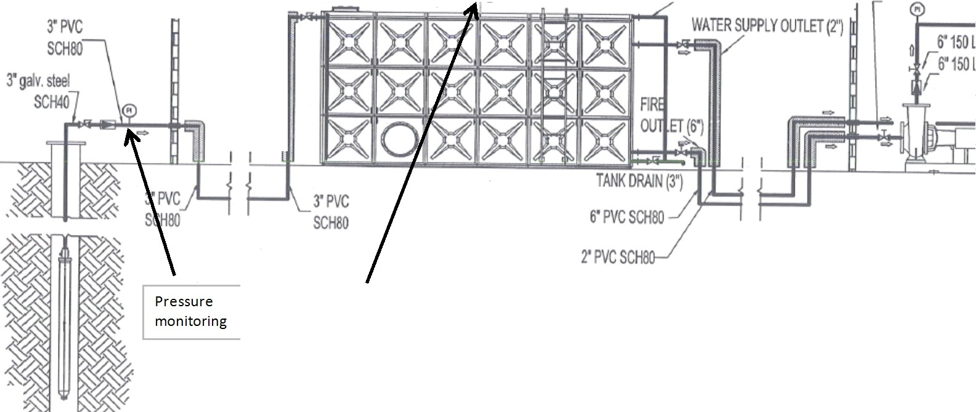

FIRE PU

750 gpm, h=

**WELL PUMP**

Fill tank to overtopping

FIRE & WATER SUPPLY SYSTEM {SCHEMATICAL)

*/i* .

WATER TANK AND WELL SOURCE DIAGRAM (Mark leaks or provide other sketch as needed)

**Figure 2 Hydraulic leakage test form completion example** I I I I I I

**Test Information (shall be grinted including names} Pressure test data** *Interval Time (h:ml Test aressure (Kaa or Psil*

Project name and location Start of te st 3 4

Contract number 1st 15 min t

Date of test 2nd 15 min I

Location of test 3rd 15 min

Name of leakage test supervisor: Completion ofte st

Name of witness

|  |  |  |
| --- | --- | --- |
|  | | |
|  |  | |
|  |  |  |
|  |  |  |
|  |
|  |  |

**t site sketch (examgle)**

I I I

**Tes**

SUPPLY SOURCE PIPE

**Leakage test data** *Interval Time (h:ml Location o[/eak*

t Start of te st (show on tank diagram above)

1st 15 min I

I 2nd 15 min

Water Tank 3rd 15 min I

4th 15 min I

|  |  |  |  |
| --- | --- | --- | --- |
|  | | !"""" |  |
| - |  |
|  | I | |

5th 15 min r

.,... 6th 15 min I

7th 15 min

Completion of te st

ISOLATION GATE VALVES

|  |  |  |  |
| --- | --- | --- | --- |
|  | | | --  - |
|  |  | |
|  |  |
|  |  |  |
|  |  |  |
|  | | | |